**Title** – In-Hospital Adverse Drug Reactions in Hospitalised Older Adults; prevalence, presentation and causative drugs – A Systematic Review and meta-analysis

E. Jennings, K. Murphy, P. Gallagher, D. O’Mahony

**Abstract**

*Background:* Adverse drug reactions (ADRs) are frequently reported as commonly occurring, increasingly costly and potentially preventable. Studies have linked multi-morbidity and polypharmacy to ADR risk. Older age predisposes to multi-morbidity and as a consequence polypharmacy. Thus, older age influences and compounds the potential for experiencing an ADR. In studies looking at all ages, the prevalence of ADRs leading to admission has been found to be lower than those occurring in hospital. Therefore, it would be sensible to predict that in-hospital ADRs would be highest in older adults with polypharmacy and multi-morbidity. However, to date no systematic review has solely looked at this.

*Aim:* This systematic review aims to identify the prevalence of in-hospital occurring ADRs in in-patients ≥ 65 years of age. In addition, we explore the reported severity, preventability, clinical presentation, causative agents and measurable outcomes of in-hospital ADRs in this cohort. We also explore the effect of the presence of multi-morbidity and polypharmacy on these variables.

*Methods:* Using PRISMA methodology [PROSPERO registration CRD42018079095], we systematically searched PubMed, Embase and Ebsco-CINAHL, Cochrane Library and library hosted academic sources, Google® scholar, and ‘grey’ literature. Search terms included aged, ADRs, hospitalized, multi-morbid, polypharmacy and hospital-acquired. A hand search of bibliography lists from relevant editorials and systematic reviews was conducted. We included studies of all languages and all dates up to and including the date of the final search [15/01/2018]. We included all studies that reported ADRs either as a primary or secondary outcome in patients aged ≥ 65 years who were hospitalised at time of ADR occurrence. Two researchers screened all papers for inclusion, risk of bias and data extraction.

*Results:* A total of 1930 abstracts were identified, following removal of duplicates 1779 were screened, 228 underwent full text screening. 23 papers reporting 22 studies, combined participants 21,306 (74% ≥ 65 years, n=15,769) were included in the final analysis. 50% (11/22) reported solely in a cohort ≥ 65 years, the remaining reported on adults – data was extractable for the ≥ 65 cohort from the paper in 5/11, while additional information was provided by the author for 6/11. 2186 patients ≥ 65 years experienced an ADR in-hospital. The mean ADR prevalence for all ≥ 65 years across included studies was 18.80% (95% CI, 14.41%-23.20%). The mean ADR prevalence in studies reporting polypharmacy and multi-morbidity (n=8/22) was 14.87%.

*Conclusion:* Almost 1-in-5 in-patients ≥ 65 years will experience a clinically significant ADR during hospitalisation. 1-in-4 of these ADRs is serious to life-threatening in severity. 2-of-3 of these ADRs are deemed preventable. 11 commonly prescribed drug classes accounted for 85% of the reported ADRs. The pattern of drugs varied for those ≥ 65 years with multi-morbidity and polypharmacy, but diuretics was the most frequently reported drug in all groups.

**Index:**

1. Introduction
2. Methods
   1. Data sources and search strategy
   2. Study selection
   3. Inclusion criteria
   4. Exclusion criteria
   5. Outcomes
      1. Primary outcomes
      2. Secondary outcomes
   6. Assessment of study quality
   7. Data extraction and synthesis
   8. Statistical analysis
      1. ADR prevalence
      2. Culprit Drugs
      3. ADR Presentation
3. Results
   1. Study selection
   2. Characteristics of included studies
   3. Study quality
   4. ADR Methodologies
   5. Reported ADR prevalence
      1. Overall
      2. ≥ 65 years all papers
      3. Papers solely ≥ 65 years
      4. Author provided additional data
   6. ADR presentation
      1. MedDRA System Organ Class
   7. ADR Culprit Drugs
      1. All papers reporting drugs ≥ 65 years
      2. ≥ 65 polypharmacy and multi-morbidity unknown
      3. ≥ 65 and presence of polypharmacy and multi-morbidity
      4. Comparison of ATC Classification
   8. Reported ADR Severity
   9. Reported ADR Preventability
   10. Presence of polypharmacy and multi-morbidity
4. Discussion
5. Conclusion

**1. Introduction:**

As per the World Health Organisation an adverse drug reactions [ADRs] is “a response to a medicine which is noxious and unintended, and which occurs at doses normally used in man”. An adverse drug event or experience (ADE) is defined as “any untoward medical occurrence that may present during treatment with a medicine but which does not necessarily have a causal relationship with this treatment” [1]. For over half a century researchers have been interested in ADRs with early observational studies focusing on ADR prevalence. Subsequently, studies focused on predictive models, associated risk factors, preventability and decreasing ADR related iatrogenic harm. For older adults in the acute care setting female sex, increased comorbid complexity, and increased number of medications are significant risk factors for experiencing an ADR [2].

Dedicated systematic reviews (SRs) focusing on ADRs have emerged in the past twenty years [3]. Yet, to date only five have focused primarily on ADRs in an older cohort in isolation [4-8]. An additional three SRs have reported on ADRs in older adults as a subset [9-11]. All of these SRs had varied settings and report the prevalence of ADRs at various time points. The reported prevalence of ADRs leading to hospitalisation in older adults lies between 8.7% to 16.6% - (8.7% [7] to 10% [2] for studies looking at older adults in isolation; 10.7% [10] to 16.6% [9] in SRs reporting subgroups of older adults). Steveneson *et al.* reported ADR prevalence to range from 6.5%-39% across acute, rehabilitation and community hospital settings [8], while Kanagaratnam *et al.* reported the prevalence to range from 4.8%-37% for older adults with cognitive disorders in a similar setting [12].

Rates of ADRs in community vs in-hospital (higher in-hospital Miguel et al. 16.8% in-hosp vs. 6.3% leading to hospitalisation all ages Kongkaew et al.). older adults 10.7% requiring admissions.

When it comes to ADRs occurring during hospitalisation, Laatikainen *et al.* found a mean prevalence of in-patient ADRs of 23.4% when exploring adverse drug events in inpatients [13]. However, the 14 included studies were adults of all ages and did not look at an older population in isolation. While Lazaou *et al.* reported 10.9% experiencing an ADR during hospitalisation across all ages [3].Only Alhawassi *et al.* has reported on prevalence of ADRs occurring in-hospital in an older adult cohort, the reported prevalence was 11.5% (95% CI, 0 – 27%) [2]. However, it is unclear as to the number of studies and size of populations represented by this value. Lazarou *et al.* found overall serious ADRs to be 6.7% (95%CI 5.2-8.2%), with those in-hospital occurring ADRs being serous in 2.1% (95% CI, 1.9-2.3%) [3]. Kanagaratnam *et al.* found for older adults with cognitive disorders serious ADRs range from 1.7-12% [12].

For older adults an in-hospital ADEs results in a prolonged inpatient length of stay [14] on average of 6.1 days [15]. Leendertse - geriatric population cost of ADE leading to hospitalisation €6,527.37 per patient [16]. Average cost of ADE-related hospital admission was €4844 with no difference comparing <65 years to 65 years [17]. Hug *et al.* cost increases with severity of ADR [18]. Khan *et al.* a hospital acquired ADR associated with a fifth more increase in cost of care (19.86% $2,401 per patient) and associated increase of 8.25% in hospital stay [19]. Field *et al.* statistically significant increase in all direct costs between 6 weeks before and after an ADE - additional $1310 for all ADEs and preventable ADEs being more $1983 [20]. In-hospital adverse drug events (ADEs) in older adults are associated with on average increased healthcare cost of €2580 [15]. Broyles et al. occurrence of ADE positively associated with length of hospital stay, daily hospital costs and total hospital costs, in addition > 70 years olds with ADE had longer LOS than those < 70 years [14]

SRs looking at interventions to reduce polypharmacy [21] and economics of adverse drug events (ADEs) [17] have been also been explored in older adults.

Despite evidence suggesting that older adults with concurrent polypharmacy and multi-morbidity are the highest risk cohort patient group for ADR occurrence, to our knowledge there isn’t a single systematic review that looks in isolation at ADRs occurring during hospitalisation in hospitalised older adults. Nor has a SR reported on ADRs in older adults with multi-morbid medical disease receiving polypharmacy. This systematic review aims to address this gap in the evidence by identifying the incidence of in-hospital occurring ADRs in hospitalised older adults. It will also aim to identify the common clinical presentations of these ADRs, the associated responsible medications, severity of ADRs and preventability. It will also identify the methods/tools utilised for the assessment of in-hospital ADRs as well as exploring associated outcomes with in-hospital ADR occurrence. In addition it will also report on ADRs in older adults with confirmed multi-morbidity and polypharmacy.

**2. Methods:**

The systematic review was registered (PROSPERO 2018 CRD42018079095) and conducted following PRISMA methodology. Two researchers (EJ and KM) were involved in the search, screening, data extraction and quality assessment process.

**2.1 Data Sources & Search Strategy**

This review focuses on in hospital-occurring ADRs or ADEs in hospitalised older adults. Search terms related to the stems elderly, Adverse Drug Reactions, Hospitalized, multi-morbid, polypharmacy and hospital acquired were utilised. Details regarding the specific search terms are available on direct request from the author. We conducted an electronic systematic search for literature in the following databases – PubMed, Embase and Ebsco-CINAHL, the Cochrane Library, as well as library hosted academic sources [i.e. thesis, poster abstracts], google scholar, and grey literature. In addition to the systematic search, bibliographic reference lists from topic relevant studies and systematic reviews were hand searched for inclusion of any relevant papers. The search included all dates from the databases' inception up to and including the date of the final search [March 2018]. We did not limit the search by language or study design. The review was limited to studies reporting on human

**2.2 Study Selection**

Studies of all design type were included. We included any study that specifically looked at, or as a subset reported on adverse drug events occurring during hospital admission / inpatient stay in our described population. After full text screening we excluded case reports, based on hierarchy of data quality. However a search of the author’s publications was conducted to ensure no subsequent relevant publications were missed. In cases where full set data was not extractable from the paper the author was contacted.

**2.3 Inclusion Criteria**

In order to be included a study had to have meet the following criteria;

* Human participants
* ≥ 65 years of age
* ADR occurrence had to be during hospitalisation
* The study had to outline a definition for what was deemed to be an ADR.
* There needed to be description of a method applied to identify the occurrence of an ADR.
* There had to be explicit assessment of causality.

We aimed to include only papers that reported on those with multimorbidity and polypharmacy. However these studies were scarce, so we deemed it acceptable to explore these as a subset of the overall systematic review.

In cases where ADRs were reported but all age data was reported and could not be separated the lead author was contacted for further clarification. Authors were also contacted for clarification when there was ambiguity regarding definitions and methods used for ADR assessment / definition.

**2.4 Exclusion Criteria**

We excluded papers that;

* Only had participants under the age of 65 years
* ADRs occurred as an outpatient, community or primary care setting
* Setting of study unclear
* As the aim of this study was to identify frequency of ADRs and associated culprit drugs in hospitalised older adults studies whose primary outcome was ADRs for a specific drug were excluded as these were deemed not to representative of our cohort.
* Non-original research papers - Editorials, commentaries, letters to the editor, review papers, systematic reviews, opinion pieces, clinical guidelines. All of such that were identified underwent bibliographic hand search as some included studies may be deemed relevant.
* Studies relating to medication errors [except those that reported ADRs as a subset]
* Studies relating to intentional overdoses.
* Studies that solely looked at ADRs/ADEs prior to, or leading to hospitalisation
* Following screening we subsequently excluded case studies on basis of hierarchical data / evidence.

**2.5 Outcomes**

***2.5.1 Primary outcomes;***

* In Hospital ADR/ADEs incidence
* In Hospital ADR/ADEs severity
* Clinical presentation of in-hospital ADR/ADE
* Drug classes accountable for in-hospital ADR/ADEs

***2.5.2 Secondary outcomes;***

* In Hospital ADR/ADEs preventability
* In Hospital ADR/ADEs Impact on length of stay
* Death due to / precipitated by ADR/ADEs
* Potentially inappropriate prescribing - PIMs/PPOs associated with In Hospital ADRs
* ICU / HDU admission as a result of In Hospital ADR/ADEs
* In hospital fall in setting of ADR/ADEs
* Discharge destination post ADR/ADEs
* Quality of life measures

**2.6 Assessment of Study Quality**

Each included paper was subjected to a risk of bias assessment individually by the two researchers [EJ and KM]. The results were compared for agreement, when non-concordance occurred discussion and a consensus was reached. The tool used depended on the design type of the included study; ROBINS-I for interventional studies, Newcastle-Ottawa scale for retrospective studies, and STROBE for cohort studies.

**2.7 Data extraction and synthesis**

*Data extraction (selection and coding):* Studies deemed suitable for inclusion were subjected to systematic data extraction using a dedicated data extraction template that was designed specifically for the purpose of this study. Each included paper had data extracted independently by the two researchers EJ and KM. Subsequently, the extracted data was compared for concordance. In cases where whole-set data was not available from the published paper, or data was originally pooled for analysis, efforts were made to contact the lead author and seek the original raw data for further review. In such cases more than one attempt was made to the lead author and then a subsequent attempt with a co-author.

In the cases of multiple study designs [ie retrospective observational, prospective cohort etc.] sub-group analysis by trial type was explored. Sub group analysis of age, degree of polypharmacy and degree of comorbidity was explored.

**2.8 Statistical Analysis**

***2.8.1 ADR Prevalence***

Statistical analysis was conducted using SPSS. We defined ADR incidence as the percentage of patients ≥65 years reported to have experienced at least one ADR during hospitalisation. We calculated the ADR percentage for each study and then explored the distribution by plotting a histogram to ascertain normality and using formal test of normality (Kolmogorov-Smirnov and Shapiro-Wilks non-significant). From this we were able to calculate the overall centrality and variability of the histogram, which would most likely be representative of the overall true measurement of centrality of ADRs in this population. We used parametric tests for normally distributed data, and non-parametric tests for non-normally distributed data.

Forest plots were produced using Review Manger® 5.3 software. *I2* values were calculates to test heterogeneity throughout the subgroup analysis, random effects model.

***2.8.2 Culprit Drugs***

Papers reported number of drugs. Reclassification into ATC hierarchy. Reported as percentage by number reported related to ADRs over total number reported drugs.

***2.8.3 ADR Presentation***

Presentations reclassified into WHO-ART and then subsequently MedDRA hierarchical system. Then reported as a percentage of overall reported ADRs.

**3. Results:**

**3.1 Study selection process**

Study Selection is outlined in the PRISMA diagram Figure 1. Systematic searching resulted in a total of 1930 abstracts being identified, 1,779 were screened, 228 underwent full-text screening. 23 papers reporting 22 studies were included in the final analysis for review [22-44]. Of these 11 studies (12 papers) [25, 26, 28, 34, 35, 38-44] reported ADRs in participants ≥ 65 years and 11 [22-24, 27, 29-33, 36, 37] reported ADRs all age adults; extractable data for ≥65 available in 5 studies [23, 32, 33, 36, 37] supplemental data for the ≥65 years cohort was provided by authors in 6 studies [22, 24, 27, 29-31].

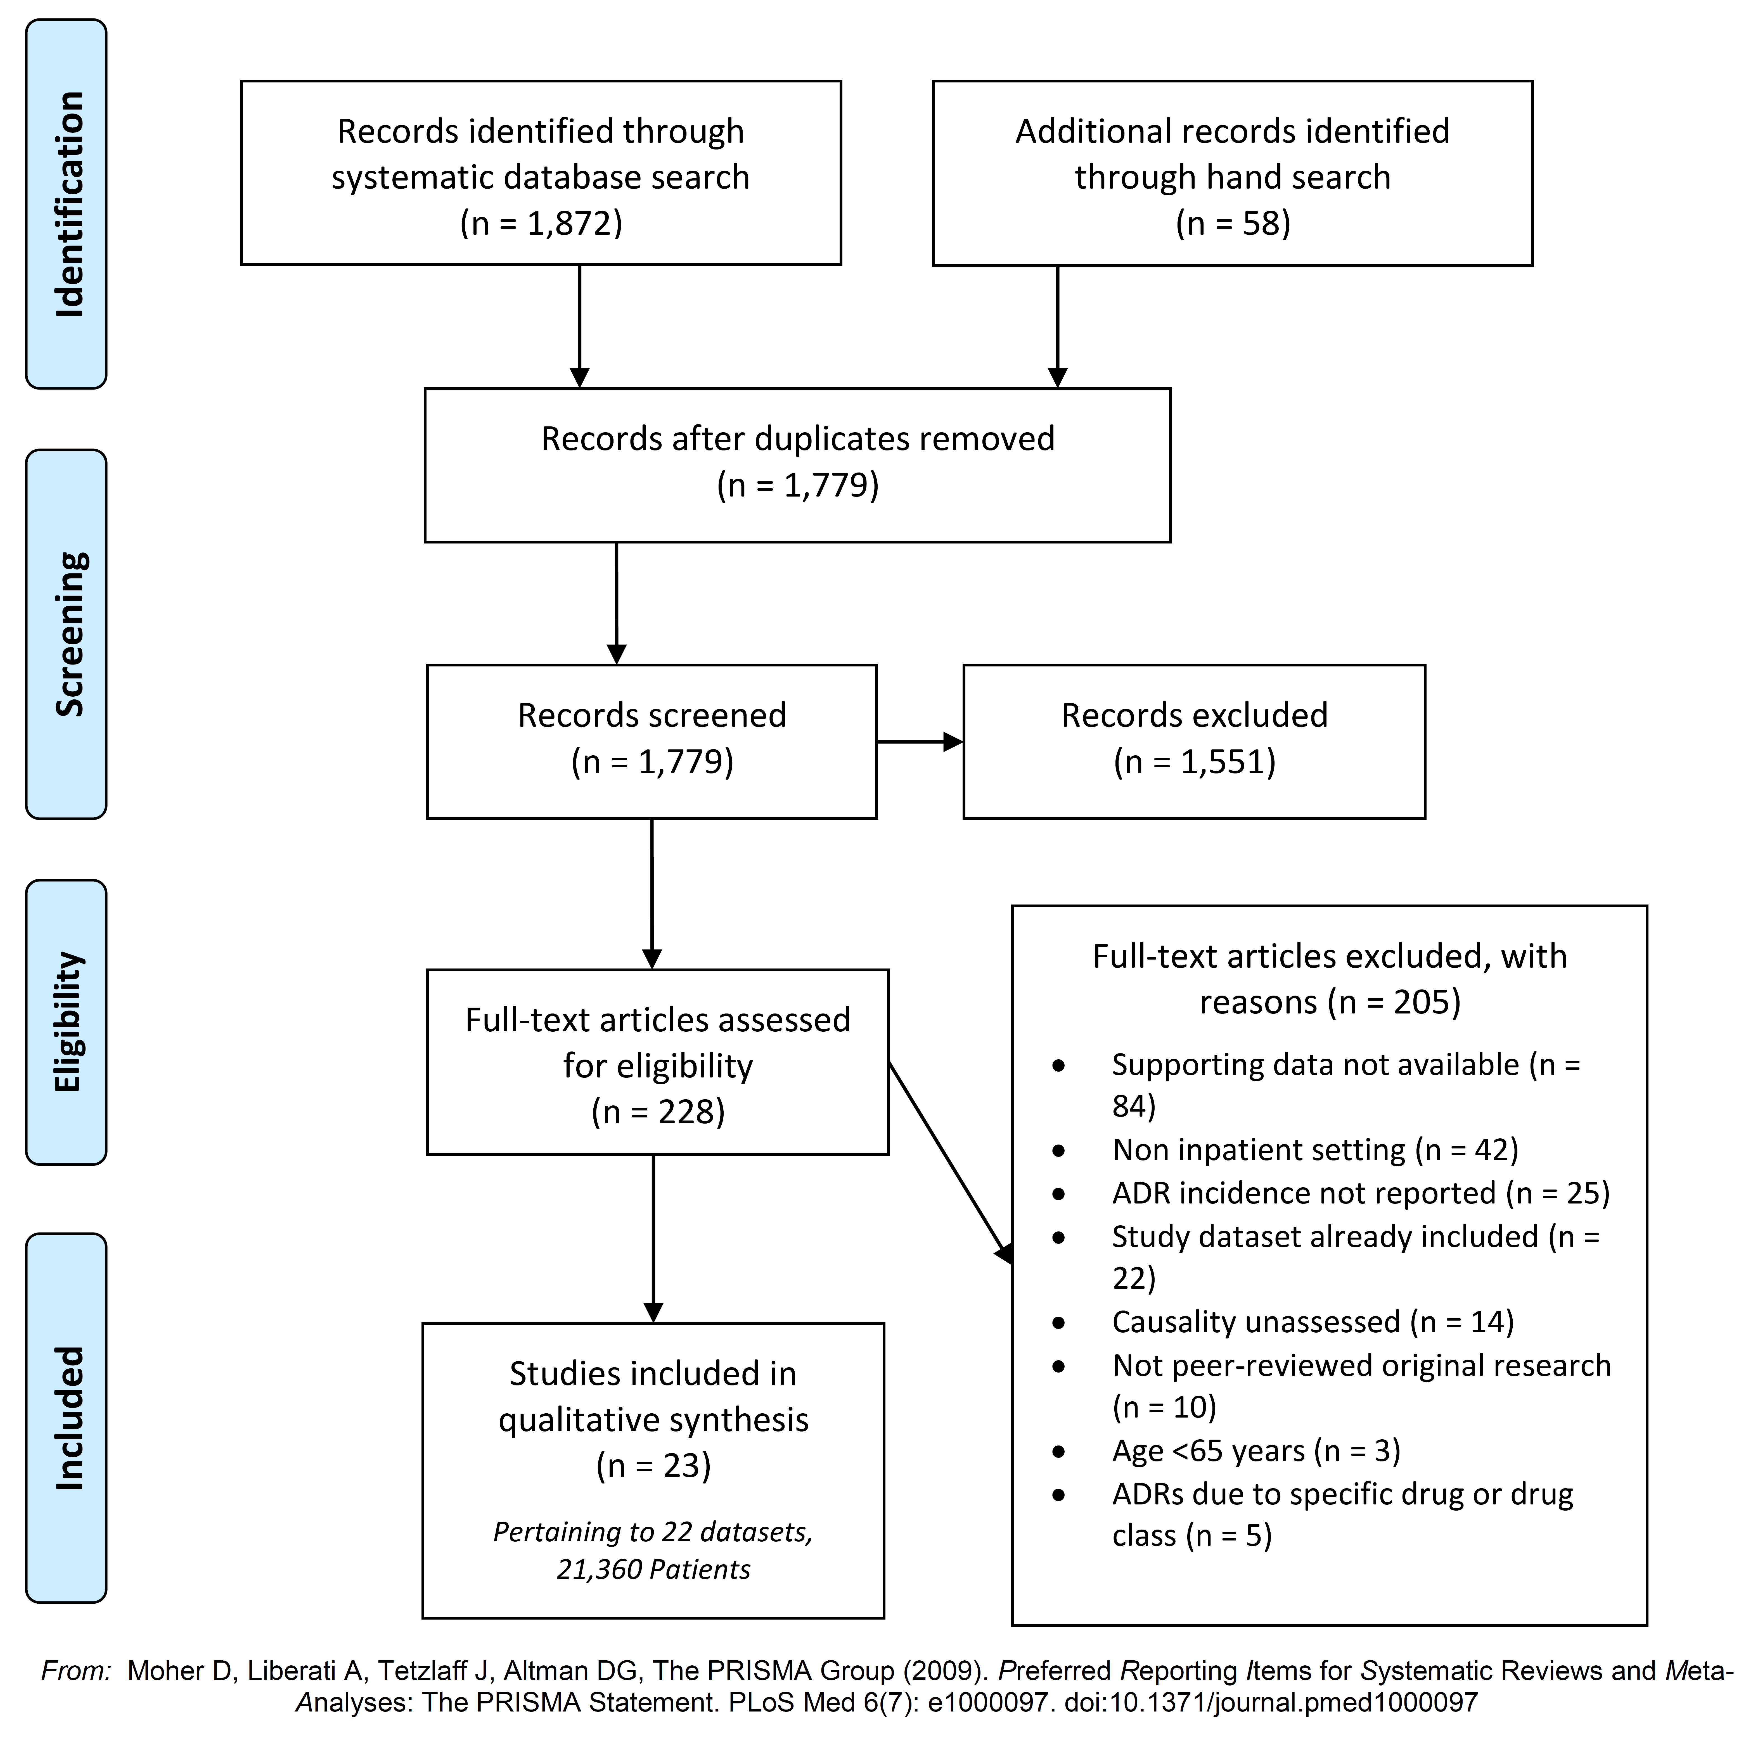

**Figure 1.** PRISMA Diagram of systematic search outputs and study selection process

**3.2 Characteristics of Included Studies**

Table 1. outlines the characteristics of the included studies. A total of 21,306 patients were included in the 22 studies. 15,769 (74%) were aged ≥65 years. Gender was reported in 18 studies [22, 24-26, 28, 29, 31-39, 41-44] – 50% male, 50% female. 2 studies reported in Spanish, 21 papers (20 studies) reported in English. Geographic distribution of publications UK 4 /23, Ireland 4/23, U.S.A 2/23, Italy 3/23, Bulgaria 3/23, Brazil 1, Colombia 1, Spain 1, Chile 1, India 1, Iran 1, Montenegro 1.

Ranged in size from 97 to 6419, published from 1965 to 2017. Included study design was predominantly observational; 20 prospective observational studies, 2 randomised control trials and one post-hoc analysis.

|  |  |  |  |  |  |  |  |  |  |  |  |
| --- | --- | --- | --- | --- | --- | --- | --- | --- | --- | --- | --- |
| **Table 1.** Characteristics of the 23 papers (22 studies) included in systematic review | | | | | | | | | | | |
| **Author** | **Year** | **Country** | **Language** | **Duration\*** | **Setting** | **Population** | **Design** | **Total N** | **N ≥ 65** | **Age** | **Gender** |
| **Ayub [22]** | 2009 | Brazil | English | 6 | Acute ICU | Adults, ICU | Prospective observational | 270 | 97 | 57.3 ± 16.3 | 57% M |
| **Bowman [23]** | 1996 | U.S.A. | English | 4 | GIM wards & ICU | Adults | Post-hoc analysis | 1024 | 301 | 54 ± 18 | - |
| **Caldron-Ospina [24]** | 2010 | Colombia | English | 1 | UH | Adults | Prospective observational | 104 | 48 | - | 54% M |
| **Conforti [25]** | 2012 | Italy | English | 6 | UH, geriatric wards | ≥ 65 years with ADRs (presenting and in-hospital) | Prospective observational | 1023 | 1023 | 81.9 ± 7.1 | 49% M |
| **Corsonello [26]** | 2009 | Italy | English | 3 | Collaborative observational group | ≥ 65 years acute medical wards | Prospective observational | 506 | 506 | 80.1 ± 6 | 46% M |
| **Davies [27]** | 2009 | U.K. | English | 6 | UH, medical and surgical wards | Adults, Monday-Friday admissions | Prospective observational | 3322 | 1787 | - | - |
| **Fernandez-Regueiro [28]** | 2011 | Spain | Spanish | 5 | Internal Medicine service | ≥ 65, ≥ 1 PIM, within 48 hours | Prospective observational | 97 | 97 | 81.3 ± 6.6 | 45% M |
| **Ganeva [29]** | 2007 | Bulgaria | English | 24 | UH, Acute dermatology service | Adults, consecutive admissions | Prospective observational | 1041 | 244 | 48.9 ± 18.9 | 42% M |
| **Ganeva [31]** | 2013 | Bulgaria | English | 18 | UH, Acute dermatology service | Adults, consecutive admissions | Prospective observational | 674 | 203 | - | 47% M |
| **Ganeva [30]** | 2016 | Bulgaria | English | 60 | UH, Acute dermatology service | Adults, consecutive admissions | Prospective observational | 750 | 222 | - | - |
| **Gonzalez-Martin [32]** | 1997 | Chile | Spanish | 8 | UH, Internal medicine | Adults. In ≥ 65 years ¥ | Prospective observational | 201 | 106 | - | 47% M |
| **Harugeri [33]** | 2011 | India | English | 18 | Tertiary hospital, medical wards | In-patient, ≥ 60 years | Prospective observational | 920 | 370 | - | 59% M |
| **Lavan [34]** | 2017 | Ireland | English | 18 | SENATOR 6 European trial sites | ≥ 65, multi-morbidity, within 72 hours | Prospective observational | 644 | 644 | 77.8 ± 7.4 | 48% M |
| **Leach [35]** | 1986 | U.K. | English | 5 | District hospital, geriatric unit | Consecutive admissions, 1 consultant | Prospective observational | 500 | 500 | 78.3 | 46% M |
| **Mohebbi [36]** | 2010 | Iran | English | 8 | 2 CCU wards | Adults, ≥1 cardiovascular drug, excl. CPR | Prospective observational | 677 | 204 | - | 65% M |
| **Mugosa [37]** | 2015 | Montenegro | English | 6 | Critical care, cardiology centre | Adults, ≥ 3 days, cognitively in-tact | Prospective observational | 200 | 64 | 60.5 ± 10 | 69% M |
| **O’Connor [38]** | 2012 | Ireland | English | 12 | UH | ≥ 65, consecutive ED admissions† | Prospective observational | 513 | 513 | 77 (72-82) | 44% M |
| **O’Connor [39]** | 2016 | Ireland | English | 4 | UH | ≥ 65, acute admissions† | Randomised control trial | 372 | 372 | 78 (72-84) | 50% M |
| **Onder [40]** | 2010 | Italy | English | 19** | 83 centres, 4 European sites | Study subset ≥ 65, hospitalised | Prospective observational | 6419 | 6419 | 78 ± 7.9 | - |
| **O’Sullivan [41]** | 2016 | Ireland | English | 13 | UH | ≥ 65, acute medical/surgical admissions | Randomised control trial | 376 | 376 | 78 (72-84) | 51% M |
| **Reichel [42]** | 1965 | U.S.A. | English | 8 | County general hospital | ≥ 65, admissions | Prospective observational | 500 | 500 | 77.9 | 43% M |
| **Tangiisuran [43]** | 2012 | U.K. | English | 6 | UHs, 4 care of elderly wards | ≥ 80*** | Prospective observational | 560** | 560** | 87 ± 5.6 | 37% M |
| **Tangiisuran [44]** | 2014 | U.K. | English | 6 | UHs, 4 care of elderly wards | ≥ 65 | Prospective observational | 1173  *690d, 483v* | 1173  *690d, 483v* | 80(75-86)d  85(81-89)v | 39% Md  42.2% Mv |
| *\* months, ICU – Intensive care unit, GIM – general internal medicine, UH – University Hospital, PIM – Potentially inappropriate medication, excl. – excluded, CCU – coronary care unit, ED – Emergency department, ¥ - excluded physical and cognitive impairment † – excluded ICU, palliative, clinical pharmacology, psychiatry, geriatric medicine, ** combined duration over (1988, 1991, 1993, 1995, 1997), ***subset of population described in 2014 paper* | | | | | | | | | | | |

**3.3. Study Quality**

|  |  |  |  |
| --- | --- | --- | --- |
| **Table: Study Quality Assessment using modified Newcastle-Ottawa Scale** | | | |
| **Author** | **Year** | **Selection**  **(Max 4 stars)** | **Outcome**  **(Max 3 stars)** |
| Ayub / Da Silva | 2009 | **** | *** |
| Bowman | 1996 | **** | *** |
| Caldron-Ospina | 2010 | **** | *-* |
| *Conforti* | 2012 | **-* | -** |
| *Corsonello* | 2009 | **** | *** |
| Davies | 2009 | **** | *** |
| *Fernandez-Regueiro* | 2011 | -*** | -** |
| Ganeva | 2016 | -**- | --* |
| Ganeva | 2013 | -**- | --* |
| Ganeva | 2007 | -**- | --* |
| Gonzalez-Martin | 1997 | ***- | *-* |
| Harugeri | 2011 | ***- | *-* |
| *Lavan* | 2017 | **** | *** |
| *Leach* | 1986 | ***- | *-* |
| Mohebbi | 2010 | ***- | *-* |
| Mugosa | 2015 | -*-- | --* |
| *O'Connor* | 2012 | ***- | *-* |
| *O'Connor†* | 2016 | N/A | N/A |
| *Onder* | 2010 | **** | *** |
| *O'Sullivan†* | 2016 | N/A | N/A |
| *Reichel* | 1965 | ***- | *** |
| *Tangiisuran* | 2012 | ***- | *** |
| 2014 | ***- | *** |
| *\* indicates study was awarded number item; - indicates the item was unclear or not described; Italics identifies studies where all participants were ≥ 65 years; † Randomised Control Trial* | | | |

**3.4. ADR Methodologies**

The methodologies employed by the included papers to assess ADRs are compared in Table 2.

*ADR Definition:* The most commonly used definition was that of WHO (14/22 studies), followed by Edward’s and Aronson (3/22); Author defined 2/22, not documented 1, local therapeutic committee 1, Bates 1.

*ADR Identification:* ADR identification methods varied between studies, varying from pharmacist led assessments to patient facing SPC specific questionnaires.

*Assessment of Causality:* Causality was most commonly assessed using Naranjo criteria (11/22), followed by WHO-UMC (6/22), not documented (3/22), Kramer (1/22), Hallas (1/22).

*Assessment of Severity:* Severity was not reported in 3 papers. Severity scales had a high tendency to be author defined 8/23 papers, lacking a standardised homogenous approach. 5/23 Hartwig, 3/23 WHO-ART, Venulet 1, national pharmacolvigilance system 1, Hurwitz 1, Morimoto 1.

*ADR Classification:* In 50% of studies (11/22) classification of ADRs was not reported, Rawlins and Thompson 5/22, WHO-ART 4/22, WHO-ART & Rawlins 1/22, Meyboom & Rawlins 1/22, DoTS 1/22

*Assessment of Preventability:* 17/22 studies did not report on ADR preventability. Hallas methodology being used in 4 of the 5 cases, Schumock & Thornton in one study.

|  |  |  |  |  |  |  |  |
| --- | --- | --- | --- | --- | --- | --- | --- |
| **Table 2. Methodologies employed by included studies in ADR identification, detection and assessment** | | | | | | | |
| **Author** | **Year** | **ADR Definition** | **Identification Method** | **Causality** | **Severity** | **Classification** | **Preventability** | |
| **Ayub [22]** | 2009 | WHO | Pharmacist, chart review at 3 TPs, adapted from National Health Surveillance Agency | Naranjo | Not documented | Rawlins & Thompson | - | |
| **Bowman [23]** | 1996 | Local therapeutic committee | 2 x Pharmacist, chart review, ≥ 3 TPs, indicator flag list and spontaneous reporting | Naranjo | Venulet | Rawlins & Thompson | - | |
| **Caldron-Ospina [24]** | 2010 | WHO | 2 x two internal physicians, daily assessment, patient questioning and panel adjudication | WHO-UMC | Author defined | DoTS | Schumock & Thornton | |
| **Conforti [25]** | 2012 | Edwards & Aronson | Nurse and Physician, "patients were monitored" | Not documented | WHO-ART | WHO-ART | - | |
| **Corsonello [26]** | 2009 | WHO | Physician, daily review of chart, laboratory results, discussion with nurse and attending physician. | Not documented | Author defined | Not documented | - | |
| **Davies [27]** | 2009 | Edwards & Aronson | Research pharmacist, daily review patients’ drug charts, medical and nursing notes. | Naranjo | Hartwig | Rawlins & Thompson | Hallas | |
| **Fernandez-Regueiro [28]** | 2011 | Bates reference | Not documented | Naranjo | Spanish system of pharmacovigilance | Not documented | - | |
| **Ganeva [29]** | 2007 | WHO | 3 x Dermatologist and pharmacologist, Structured review past medical and drug history, laboratory tests, clinical description of adverse event and outcome. | Naranjo | Author defined | WHO-ART & Rawlins | - | |
| **Ganeva [31]** | 2013 | WHO | Medical chart review | Naranjo | author defined – “clinical judgement" mild, moderate, severe" | WHO-ART | - | |
| **Ganeva [30]** | 2016 | WHO | Screened during clinical rounds, analysis of laboratory data. | Naranjo | Hartwig | WHO-ART | Hallas | |
| **Gonzalez-Martin [32]** | 1997 | Author defined - prior publication | The pharmacovigilance described by the Boston Collaborative Drug Surveillance Program | Naranjo | Author defined - lethal, severe, moderate | Not documented | - | |
| **Harugeri [33]** | 2011 | WHO | Pharmacist, daily review of chart, laboratory and nursing notes. | Naranjo | Hartwig | WHO-ART | - | |
| **Lavan [34]** | 2017 | WHO | Application of trigger list at recruitment and then retrospectively at D14/DC, all cases adjudicated | WHO-UMC | Hartwig | Not documented | - | |
| **Leach [35]** | 1986 | WHO | Patient interview and notes review | Kramer | Hurwitz | Rawlins & Thompson | - | |
| **Mohebbi [36]** | 2010 | WHO | Pharmacist; daily patient interview, chart and lab results review; confirmatory discussion with physicians | WHO-UMC | WHO-ART | Not documented | - | |
| **Mugosa [37]** | 2015 | WHO | SPC/ADR specific questionnaire and patient interview, discussion between interviewer and physician | Naranjo | WHO-ART | Meyboom, Rawlins and System organ | - | |
| **O’Connor [38]** | 2012 | Not Documented | Physician; review of medications labs and notes at D5 & D10; patient and physician consultation | WHO-UMC | Author defined - severe, moderate, mild | Not documented | - | |
| **O’Connor [39]** | 2016 | WHO | Not documented | WHO-UMC | Author defined | Not documented | Hallas | |
| **Onder [40]** | 2010 | WHO | Physician; daily review of nursing and medical notes | Naranjo | Author defined | Not documented | - | |
| **O’Sullivan [41]** | 2016 | WHO | Pharmacist; D7-10/DC interview with patient or NOK; review of notes, labs, kardex and trigger list. ADRs adjudicated by geriatrician. | WHO-UMC | Hartwig | Not documented | - | |
| **Reichel [42]** | 1965 | Author defined - "new problem" | Physician; daily chart review - labs, medical and nursing notes, kardex, investigations, autopsy reports | Not documented | Not documented | Not documented | - | |
| **Tangiisuran [43]** | 2012 | Edwards & Aronson | 3 step process – identify confirm and classify; daily review of labs, notes, prescriptions | Hallas | Morimoto | Rawlins & Thompson | Hallas | |
| **Tangiisuran [44]** | 2014 | Edwards & Aronson D  Not documented V | Primary investigator trigger tool and review of medical and nursing notes, labs, drug charts and incident forms | Hallas D  Naranjo V | Not documented | Not documented | - | |
| *TP – Time point, D – Day, DC – Discharge, SPC – Summaries of Product Characteristics, NOK – next of kin,  D – development group, V – validation group* | | | | | | | |

* 1. **ADR Prevalence**

***3.5.1 Overall Reported ADR Prevalence***

22 studies (23 papers) reported ADR incidence in 15,769 patients ≥ 65 years (21,306 patients overall). The ADR event numbers for all included studies / papers as a total of all reported participants adults and those aged ≥ 65 years are shown in Table 3. The overall total ADR mean prevalence for ADRs for all ages reported in the 22 studies was 17.92% (95% CI, 13.96% - 21.88%).

|  |  |  |  |  |  |  |  |
| --- | --- | --- | --- | --- | --- | --- | --- |
| Table 3.: Reported ADR events for included papers/studies | | | | | | | |
| Author | Paper Total N | Paper total n pt ≥ 1 ADR | Paper total % pt ADR | n ≥ 65 | % of N ≥65 | ≥ 65 pt ADRs | % pt ≥ 65 ADR |
| Ayub [22] | 270 | 20 | 7.41 | 97 | 35.93 | 7 | 7.22 |
| Bowman [23] | 1024 | 237 | 23.14 | 301 | 29.39 | 89 | 29.57 |
| Caldron-Ospina [24] | 104 | 26 | 25.00 | 48 | 46.15 | 11 | 22.92 |
| Davies [27] | 3322 | 545 | 16.41 | 1787 | 53.79 | 328 | 18.35 |
| Ganeva [31] | 674 | 42 | 6.23 | 203 | 30.12 | 19 | 9.36 |
| Ganeva [30] | 750 | 22 | 2.93 | 222 | 29.60 | 11 | 4.95 |
| Ganeva [29] | 1041 | 81 | 7.78 | 244 | 23.44 | 15 | 6.15 |
| Gonzalez-Martin [32] | 201 | 58 | 28.86 | 106 | 52.74 | 35 | 33.02 |
| Harugeri [33] | 920 | 296 | 32.17 | 370 | 40.22 | 112 | 30.27 |
| Mohebbi [36] | 677 | 164 | 24.22 | 204 | 30.13 | 46 | 22.55 |
| Mugosa [37] | 200 | 66 | 33.00 | 64 | 32.00 | 27 | 42.19 |
| Conforti [25] * | 1023 | 256 | 25.02 | 1023 | 100.00 | 256 | 25.02 |
| Corsonello [26] * | 506 | 58 | 11.46 | 506 | 100.00 | 58 | 11.46 |
| Fernandez-Regueiro [28] * | 97 | 12 | 12.37 | 97 | 100.00 | 12 | 12.37 |
| Lavan [34] * | 644 | 139 | 21.58 | 644 | 100.00 | 139 | 21.58 |
| Leach [35] * | 500 | 94 | 18.80 | 500 | 100.00 | 94 | 18.80 |
| O’Connor [38] * | 513 | 135 | 26.32 | 513 | 100.00 | 135 | 26.32 |
| O’Connor [39] * | 372 | 78 | 20.97 | 372 | 100.00 | 78 | 20.97 |
| Onder [40] * | 6419 | 439 | 6.84 | 6419 | 100.00 | 439 | 6.84 |
| O’Sullivan [41] * | 376 | 78 | 20.74 | 376 | 100.00 | 78 | 20.74 |
| Reichel [42]* | 500 | 54 | 10.80 | 500 | 100.00 | 54 | 10.80 |
| Tangiisuran [44] * | 1173 | 143 | 12.19 | 1173 | 100.00 | 143 | 12.19 |
| Tangiisuran [43]** | *560* | *74* | *13.21* | *560* | *100.00* | *74* | *13.21* |
| *\*indicates study where entire study population was ≥ 65 years, ** subset of population described in 2014 paper* | | | | | | | |

***3.5.2 Reported ADR prevalence ≥ 65 years (all papers)***

A total of 2186 patients aged ≥ 65 years experienced ADRs in-hospital, giving an absolute ADR prevalence of 13.87%. However, given the heterogeneity in ADR methodologies employed (Table 2.), we plotted the distribution of the individual studies reported ADR prevalence and calculated the mean ADR prevalence to be 18.80% SD ±9.9 (95% CI 14.41 – 23.20%) min 4.95% max 42.19% in those ≥ 65 years.

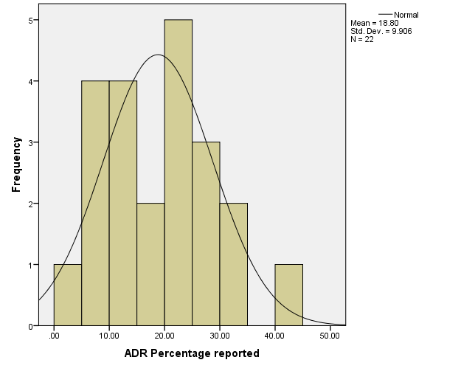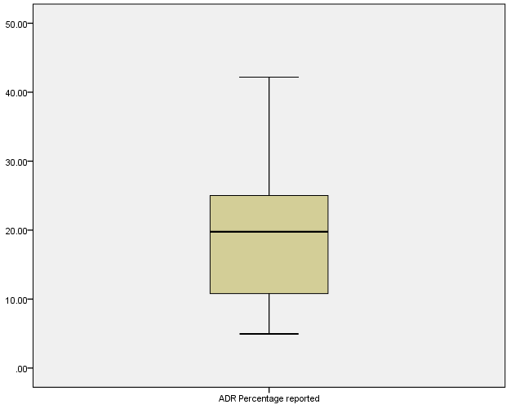

***3.5.3 ADR prevalence in studies where population was solely ≥ 65 years***

The ADR prevalence were plotted for studies where ≥ 65 years only at inclusion and then for studies where data for those aged ≥ 65 years were a subset of the overall population. Samples were normally distributed when plotted on histogram and using formal test of normality (Kolmogorov-Smirnov and Shapiro-Wilks non-significant).Mean ADR rates were lower in studies solely looking at ≥65 years compared to studies that reporting ADRs in ≥65 as a subset of all ages. ADR rates in papers where the overall population was ≥65 years for whole population mean 17.00% ± 6.5% (12.6 – 21.4%). ADR rates in papers where the overall population were all ages 20.6% ±12.5% (12.2 – 29.0%). Comparing means of two groups using Independent sample test this difference was not statistically significant p >0.05.

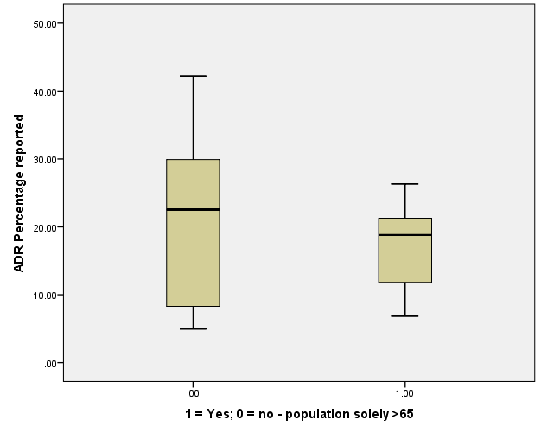

***3.5.4 ADR rates in individuals ≥ 65 years and provided in author additional data***

Further subgroup analysis – papers where additional author data was required for ADRs ≥ 65 years (0=No, 1=Yes). Samples were normally distributed when plotted on histogram and using formal test of normality (Kolmogorov-Smirnov and Shapiro-Wilks non-significant).

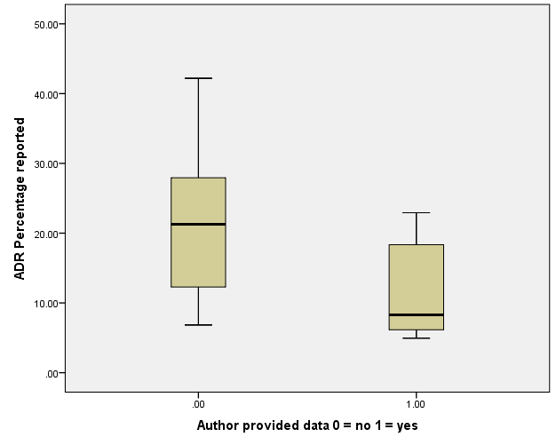

The mean ADR was lower in the author-supplied data group 11.49% ± 7.37% (3.75-19.23) vs studies not requiring author data 21.54% ± 9.48 (16.49-26.59). Mean difference 10.05% SE 3.83 (1.68-18.43) p = 0.023.

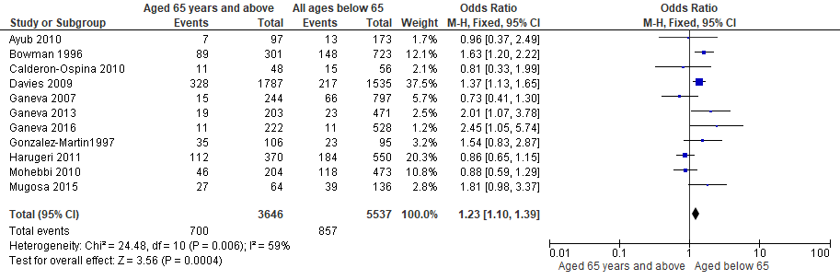

Meta-analysis for ADR events occurring in those aged 65 years and over versus ADRs occurring in those aged below 65.

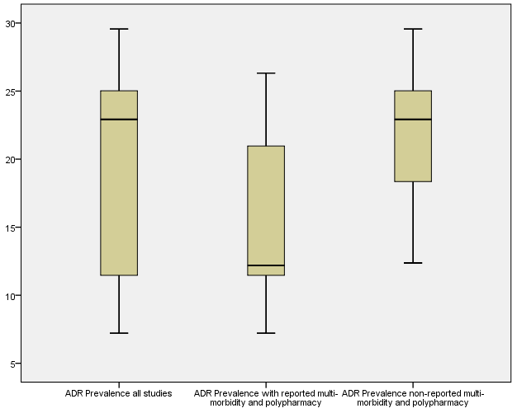

Boxplots representing sensitivity analysis comparing the ADR prevalence across all studies, those where polypharmacy and multi-morbidity were reported as being presence and those where polypharmacy and multi-morbidity status is unknown.

**3.6 Reported ADR Presentation**

16 studies, 73% [22-27, 29-32, 35, 38-42] reported on 1,403 ADR presentations, occurring in 1,476 patients ≥ 65 years. We are unable to report the absolute number of ADRs because not all papers reported on all ADR events. Some papers only reported an ADR presentation when at least 2 patients experienced it. Therefore, our proportions of ADR presentations are based on the number specific to the individual presentation as the numerator and overall number of reported ADR presentations as the denominator (1,403).

Studies reported ADRs using different methods, but in general an approach similar to WHO-ART or organ system was employed. We assessed and regrouped the presentations to resemble that of WHO-ART terminology and then further reclassified to reflect the current standard of MedDRA system organ classes. In some cases, studies reported the ADRs in a bespoke regrouping that overlapped across multiple WHO-ART and MedDRA subgroups. In these cases, when no clear number could be accurately identified we excluded them in further analysis.

The most common ADR presentations are shown in *Table 4.* From those reported and suitable for reclassification the top 5 presentations accounted for over three quarters of the ADRs – metabolism and nutritional disorders 20% (283); nervous system disorders 17% (246); cardiac disorders 15% (210); gastro-intestinal disorders 13% (185); renal and urinary disorders 10% (148).

|  |  |  |
| --- | --- | --- |
| **Table 4. Reported ADR presentations as per MedDRA Classification and as a proportion of overall reported ADRs** | | |
| ***MedDRA System Organ Class Terminology*** | ***Overall ADR System Organ Class #*** | ***% of ADRS [1403]*** |
| Metabolism and nutrition disorders | 283 | 20.2 |
| Nervous system disorders | 246 | 17.5 |
| Cardiac disorders | 210 | 15.0 |
| Gastrointestinal Disorders | 185 | 13.2 |
| Renal and urinary disorders | 148 | 10.5 |
| Blood and Lymphatic System Disorders | 80 | 5.7 |
| Immune System Disorders | 57 | 4.1 |
| Injury, poisoning and procedural complications | 50 | 3.6 |
| Skin and subcutaneous tissue disorders | 48 | 3.4 |
| Vascular disorders | 21 | 1.5 |
| Endocrine Disorders | 18 | 1.3 |
| Infections and infestations | 18 | 1.3 |
| Respiratory, thoracic and mediastinal disorders | 8 | 0.6 |
| Musculoskeletal and connective tissue disorders | 6 | 0.4 |
| General disorders and administration site conditions | 5 | 0.4 |
| Eye Disorders | 4 | 0.3 |
| Ear and labyrinth Disorders | 2 | 0.1 |
| Hepatobiliary Disorders | 2 | 0.1 |

*Can we look at the top presenting groups and see what is most common of each – if possible at all? – for metabolism and nutrition it’s likely electrolyte disturbance.*

*Go back into the presentations for the subgroups like for culprit drugs - ? Polypharmacy and multi-morbidity group present differently?*

***3.7 ADR Drugs***

15 papers [22, 24-27, 29-32, 35, 38, 39, 41-43] reported on drugs associated with ADRs in those aged 65 years or above occurring in hospital. A total of 1528 drugs were reported, accounting for 1,253 patients. 85% of ADRs were associated with 11 commonly prescribed medications. Reporting varied across the papers, with some reporting by drug name, drug group and ATC code subgroup. Additionally some papers only reported if the drug was suspected in cohorts of patients and not single cases (i.e ≥ 3 cases). We extracted all available details on drugs deemed accountable for the assessed ADRs. We then sub-grouped the reported drugs by common ATC groups and reported the numbers as percentages of reported drug number. Given the lack of common methodology between studies we could not report as percentage of ADRs. *REPORTED AS % OF N DRUGS PER INCLUDED STUDIES; Some papers reported # pts and others # ADRs so hence only constant to make comparable statements is proportion by number of reported drugs.

|  |  |  |  |  |  |
| --- | --- | --- | --- | --- | --- |
| **Table 5: Culprit drugs reported as per ATC Classification, and proportion of overall reported drugs** | | | | | |
| **ATC Classification** | **n** | **% (of 1528)** | **Specific drug / class [rank top 20]** | **n** | **% (of 1528)** |
| **C - Cardiovascular System** | **545** | **35.67** | *Cardiovascular system – Diuretics [1]* | 339 | 22.19 |
|  |  |  | *Cardiovascular System – agents acting on renin-angiotensin system [7]* | 56 | 3.66 |
|  |  |  | Cardiovascular system – cardiac therapy – cardiac glycosides [11] | 41 | 2.68 |
|  |  |  | Cardiovascular System – Antihypertensives [12] | 38 | 2.49 |
|  |  |  | Cardiovascular System - beta-blocking agents [15] | 30 | 1.96 |
|  |  |  | Cardiovascular system – calcium-channel blockers [18] | 16 | 1.05 |
|  |  |  | Cardiovascular System – cardiac therapy (amiodarone, nitrates) [19] | 14 | 0.92 |
|  |  |  | Cardiovascular System | 8 | 0.52 |
|  |  |  | Cardiovascular system – lipid modifying agents | 3 | 0.20 |
| **N - Nervous system** | **298** | **19.50** | *Nervous system – Analgesics – opioids [3]* | 135 | 8.84 |
|  |  |  | *Nervous system – Psycholeptics [5]* | 87 | 5.69 |
|  |  |  | *Nervous system – Analgesics [8]* | 55 | 3.60 |
|  |  |  | Nervous System – Psychoanaleptics | 10 | 0.65 |
|  |  |  | Nervous System – antiepileptics | 8 | 0.52 |
|  |  |  | Nervous system – Anti-Parkinson Drugs | 2 | 0.13 |
|  |  |  | Nervous System – parasympathomimetics | 1 | 0.07 |
| **B - Blood and blood forming organs** | **228** | **14.92** | *Blood and blood forming organs – Antithrombotic Agents – Vitamin K antagonists [4]* | 154 | 10.08 |
|  |  |  | Blood and blood forming organs – Antithrombotic Agents – Heparin Group [16] | 29 | 1.90 |
|  |  |  | Blood and blood forming organs – Antithrombotic Agents – platelet aggregation inhibitors [17] | 26 | 1.70 |
|  |  |  | Blood and blood forming agents – antianaemic preparations [20] | 12 | 0.79 |
|  |  |  | Blood and blood forming organs - Blood substitutes and perfusion solutions | 7 | 0.46 |
| **J - Antiinfectives for Systemic use** | **184** | **12.04** | *Antiinfectives for Systemic use [2]* | 184 | 12.04 |
| **A - Alimentary tract and metabolism** | **92** | **6.02** | *Alimentary tract and metabolism – drugs used in diabetes [6]* | 63 | 4.12 |
|  |  |  | Alimentary tract and metabolism – Mineral Supplements | 8 | 0.52 |
|  |  |  | Alimentary tract and metabolism – Drugs for constipation | 6 | 0.39 |
|  |  |  | Alimentary tract and metabolism – drugs for functional gastrointestinal disorders | 3 | 0.20 |
|  |  |  | Alimentary tract and metabolism – Vitamins | 1 | 0.07 |
|  |  |  | Drugs for peptic ulcer and gastro-oesophageal reflux disease (GORD) | 11 | 0.72 |
| **R - Respiratory system** | **55** | **3.60** | *Respiratory system - Drugs for obstructive airway disease [10]* | 42 | 2.75 |
|  |  |  | Respiratory system – corticosteroids | 9 | 0.59 |
|  |  |  | Respiratory system – Antihistamines for systemic use | 2 | 0.13 |
|  |  |  | Respiratory system – cough and cold preparations | 2 | 0.13 |
| **H - Systemic hormonal preparations, excl. Sex hormones and insulins** | **46** | **3.01** | *Systemic hormonal preparations, excl. Sex hormones and insulins - corticosteroids for systemic use [9]* | 46 | 3.01 |
| **M - Musculo-skeletal system** | **40** | **2.62** | Musculo-skeletal system – anti-inflammatory and antirheumatic products (NSAIDs) [14] | 32 | 2.09 |
|  |  |  | Musculo-skeletal system – Antigout preparations | 5 | 0.33 |
|  |  |  | Musculo-skeletal system – Drugs for the treatment of bone diseases | 2 | 0.13 |
|  |  |  | Musculo-skeletal system – muscle relaxants | 1 | 0.07 |
| **V - Various** | **33** | **2.16** | Various [13] | 33 | 2.16 |
| **L - Antineoplastic and immunomodulating agents** | **2** | **0.13** | Antineoplastic and immunomodulating agents | 2 | 0.13 |
| **P - Antiparasitic products** | **2** | **0.13** | Antiparasitic products | 2 | 0.13 |
| **G - Genito urinary system and sex hormones** | **2** | **0.13** | Genito urinary system and sex hormones – Urologicals | 2 | 0.13 |
| **D - Dermatologics** | **1** | **0.07** | Dermatologics | 1 | 0.07 |
| *Indicates those in top 10* | | | | | |

***3.8 ADR Severity***

15 studies [23-27, 29-32, 35, 38-41, 43] reported severity (n = 13,171; reported ADRs = 1,947). 72% of reported ADRs were at least of moderate severity. 29% (560 ADRs) were severe. *[Check these numbers ? n reported based on 14 studies]*

***3.9 ADR Preventability***

5 studies [24, 27, 30, 39, 43] assessed preventability (n = 3602, reporting 672 ADRs), 69% of reported ADRs were preventable.

***3.10 Polypharmacy and Multi-morbidity***

Polypharmacy (reported as a mean/median ≥5 medications at baseline) was reported and present in 11 studies [22, 26, 28, 31, 34, 35, 38-41, 44]. Multi-morbidity (reported as a mean/median number of diagnoses ≥3 at baseline) was reported in 9 and present in 8 studies [22, 26, 28, 34, 38-40, 44] (in two cases [38, 39] multi-morbidity was not described in the primary published paper, but was described in a subsequent publication [45])

ADRs occurred in 14.87% +/- 7.18% in the 8 studies that reported both polypharmacy and multi-morbidity; min 4.95 max 26.32. Data regarding culprit drugs for ADRs in this subset was only available for 5 [22, 26, 38, 39, 43] of the 8 studies, accounting for 466 ADRs, 461 drugs.

|  |  |  |  |  |
| --- | --- | --- | --- | --- |
| ***Table 6: Culprit drugs for ≥ 65 multi-morbidity polypharmacy ADRs*** | | | | |
| Rank | **Culprit Drug** | **N** | **As % # ADRs** | **% #ADR Drugs** |
| 1 | Diuretics | 76 | 16.31 | 16.49 |
| 2 | opioids | 67 | 14.38 | 14.53 |
| 3 | benzodiazepines | 52 | 11.16 | 11.28 |
| 4 | antibacterials | 29 | 6.22 | 6.29 |
| 5 | antihypertensives | 24 | 5.15 | 5.21 |
| 6 | NSAIDs | 19 | 4.08 | 4.12 |
| 7 | beta-blocking agents | 18 | 3.86 | 3.90 |
| 8 | Angiotensin-converting enzyme inhibitors | 13 | 2.79 | 2.82 |
| 9 | antiplatelets | 12 | 2.58 | 2.60 |
| 10 | warfarin | 11 | 2.36 | 2.39 |
| 11 | insulin or analogues | 10 | 2.15 | 2.17 |
| 12 | others | 10 | 2.15 | 2.17 |
| 13 | anticoagulants | 9 | 1.93 | 1.95 |
| 14 | calcium-channel blockers | 9 | 1.93 | 1.95 |
| 15 | ACE-I ARBs | 8 | 1.72 | 1.74 |
| 16 | cardiovascular agents | 8 | 1.72 | 1.74 |
| 17 | Heparin | 8 | 1.72 | 1.74 |
| 18 | oral hypoglycaemic agents | 7 | 1.50 | 1.52 |
| 19 | cardiac glycosides | 5 | 1.07 | 1.08 |
| 20 | antiepileptics | 4 | 0.86 | 0.87 |
| 21 | Antithrombotic agents | 4 | 0.86 | 0.87 |
| 22 | Aspirin | 4 | 0.86 | 0.87 |
| 23 | Iron supplement | 4 | 0.86 | 0.87 |
| 24 | antipsychotics | 3 | 0.64 | 0.65 |
| 25 | glucocorticoids | 3 | 0.64 | 0.65 |
| 26 | neuroleptics | 3 | 0.64 | 0.65 |
| 27 | propulsives | 3 | 0.64 | 0.65 |
| 28 | psychotropics | 3 | 0.64 | 0.65 |
| 29 | SSRIs | 3 | 0.64 | 0.65 |
| 30 | Vancomycin | 3 | 0.64 | 0.65 |
| 31 | amiodarone | 2 | 0.43 | 0.43 |
| 32 | analgesics and antipyretics | 2 | 0.43 | 0.43 |
| 33 | angiotensin-2 receptor antagonists | 2 | 0.43 | 0.43 |
| 34 | dopaminergics | 2 | 0.43 | 0.43 |
| 35 | nitrates | 2 | 0.43 | 0.43 |
| 36 | xanthines | 2 | 0.43 | 0.43 |
| 37 | allopurinol | 1 | 0.21 | 0.22 |
| 38 | aminoquinolines | 1 | 0.21 | 0.22 |
| 39 | amitriptyline | 1 | 0.21 | 0.22 |
| 40 | anticholinesterases | 1 | 0.21 | 0.22 |
| 41 | antihistamines | 1 | 0.21 | 0.22 |
| 42 | Cefepime | 1 | 0.21 | 0.22 |
| 43 | cough supppressant, opium alkaloid | 1 | 0.21 | 0.22 |
| 44 | doxazosin | 1 | 0.21 | 0.22 |
| 45 | Fentanyl | 1 | 0.21 | 0.22 |
| 46 | hypnotics and sedatives | 1 | 0.21 | 0.22 |
| 47 | laxatives | 1 | 0.21 | 0.22 |
| 48 | mucolytics | 1 | 0.21 | 0.22 |
| 49 | Potassium- sparing diuretics | 1 | 0.21 | 0.22 |
| 50 | potassium supplements | 1 | 0.21 | 0.22 |
| 51 | Salbutamol | 1 | 0.21 | 0.22 |
| 52 | Sodium citrate | 1 | 0.21 | 0.22 |
| 53 | solution for parentral nutrition | 1 | 0.21 | 0.22 |

|  |  |  |  |  |  |
| --- | --- | --- | --- | --- | --- |
| ***Table 7: Culprit drugs reported in 5 studies with multi-morbidity and polypharmacy for ADRs regrouped by ATC code, 461 drugs accounting for 466 ADRs*** | | | | | |
|  | **New Grouping** | **ATC** | **n** | **as % of #ADRs** | **as % # Drugs** |
| 1 | Cardiovascular system – Diuretics | C03 | 77 | 16.52 | 16.70 |
| 2 | Nervous system – Analgesics – opioids | N02A | 68 | 14.59 | 14.75 |
| 3 | Nervous system – Psycholeptics | N05 | 62 | 13.30 | 13.45 |
| 4 | Antiinfectives for Systemic use | J | 33 | 7.08 | 7.16 |
| 5 | Cardiovascular System – Antihypertensives | C02 | 25 | 5.36 | 5.42 |
| 6 | Blood and blood forming organs – Antithrombotic Agents – Vitamin K antagonists | B01A | 24 | 5.15 | 5.21 |
| 7 | Cardiovascular System – agents acting on renin-angiotensin system | C09 | 23 | 4.94 | 4.99 |
| 8 | Musculo-skeletal system – anti-inflammatory and antirheumatic products | M01 | 19 | 4.08 | 4.12 |
| 9 | Cardiovascular System - beta-blocking agents | C07 | 18 | 3.86 | 3.90 |
| 10 | Alimentary tract and metabolism – drugs used in diabetes | A10 | 17 | 3.65 | 3.69 |
| 11 | Blood and blood forming organs – Antithrombotic Agents – platelet aggregation inhibitors | B01AC | 16 | 3.43 | 3.47 |
| 12 | Various | V | 10 | 2.15 | 2.17 |
| 13 | Cardiovascular system – calcium-channel blockers | C08 | 9 | 1.93 | 1.95 |
| 14 | Cardiovascular System | C | 8 | 1.72 | 1.74 |
| 15 | Blood and blood forming organs – Antithrombotic Agents – Heparin Group | B01AB | 8 | 1.72 | 1.74 |
| 16 | Cardiovascular system – cardiac therapy – cardiac glycosides | C01A | 5 | 1.07 | 1.08 |
| 17 | Cardiovascular System – cardiac therapy | C01 | 4 | 0.86 | 0.87 |
| 18 | Blood and blood forming agents – antianaemic preparations | B03 | 4 | 0.86 | 0.87 |
| 19 | Nervous System - Psychoanaleptics | N06 | 4 | 0.86 | 0.87 |
| 20 | Nervous System - antiepileptics | N03 | 4 | 0.86 | 0.87 |
| 21 | Respiratory system - Drugs for obstructive airway disease | R03 | 3 | 0.64 | 0.65 |
| 22 | Alimentary tract and metabolism – drugs for functional gastrointestinal disorders | A03 | 3 | 0.64 | 0.65 |
| 23 | Systemic hormonal preparations, excl. Sex hormones and insulins - corticosteroids for systemic use | H | 3 | 0.64 | 0.65 |
| 24 | Blood and blood forming organs - Blood substitutes and perfusion solutions | B05 | 2 | 0.43 | 0.43 |
| 25 | Respiratory system – cough and cold preparations | R05 | 2 | 0.43 | 0.43 |
| 26 | Nervous system – Analgesics | N02 | 2 | 0.43 | 0.43 |
| 27 | Nervous system – Anti-Parkinson Drugs | N04 | 2 | 0.43 | 0.43 |
| 28 | Antiparasitic products | P | 1 | 0.21 | 0.22 |
| 29 | Musculo-skeletal system – Antigout preparations | M04 | 1 | 0.21 | 0.22 |
| 30 | Respiratory system – Antihistamines for systemic use | R06 | 1 | 0.21 | 0.22 |
| 31 | Nervous System - parasympathomimetics | N07A | 1 | 0.21 | 0.22 |
| 32 | Alimentary tract and metabolism – Mineral Supplements | A12 | 1 | 0.21 | 0.22 |
| 33 | Alimentary tract and metabolism – Drugs for constipation | A06 | 1 | 0.21 | 0.22 |

|  |  |  |
| --- | --- | --- |
| ***Table 8: Distribution of ATC Classification of ADRs in multi-morbid and Polypharmacy*** | | |
| **ATC Grouping (multi-morbidity and polypharmacy -5 studies)** | **n ADR Drugs** | **as % of n Drugs** |
| C - Cardiovascular System | 169 | 36.66 |
| N – Central Nervous System | 143 | 31.02 |
| B – Blood and blood forming organs | 54 | 11.71 |
| J – General Antiinfectives, systemic | 33 | 7.16 |
| A – Alimentary tract and metabolism | 22 | 4.77 |
| M – Musculo-skeletal system | 20 | 4.34 |
| V – Various | 10 | 2.17 |
| R – Respiratory system | 6 | 1.30 |
| H – Systemic Hormonal preparations, excl. sex hormones | 3 | 0.65 |
| P – Antiparasitic products | 1 | 0.22 |
| L – Antineoplastics and immunosuppressants | 0 | 0.00 |
| D – Dermatologics | 0 | 0.00 |
| G – Genito-urinary system and sex hormones | 0 | 0.00 |

|  |  |  |  |  |
| --- | --- | --- | --- | --- |
| ***Table 9. Non-reported polypharmacy multi-morbidity papers [24, 25, 27, 29-32, 35, 41, 42] culprit drugs*** | | | | |
| **Rank** | **New Grouping** | **Total N** | **% #ADRs** | **% ADR Drugs** |
| 1 | Cardiovascular system – Diuretics | 262 | 24.35 | 24.55 |
| 2 | Antiinfectives for Systemic use | 151 | 14.03 | 14.15 |
| 3 | Blood and blood forming organs – Antithrombotic Agents – Vitamin K antagonists | 130 | 12.08 | 12.18 |
| 4 | Nervous system – Analgesics – opioids | 101 | 9.39 | 9.47 |
| 5 | Alimentary tract and metabolism – drugs used in diabetes | 46 | 4.28 | 4.31 |
| 6 | Systemic hormonal preparations, excl. Sex hormones and insulins - corticosteroids for systemic use | 43 | 4.00 | 4.03 |
| 7 | Respiratory system - Drugs for obstructive airway disease | 39 | 3.62 | 3.66 |
| 8 | Cardiovascular system – cardiac therapy – cardiac glycosides | 36 | 3.35 | 3.37 |
| 9 | Cardiovascular System – agents acting on renin-angiotensin system | 33 | 3.07 | 3.09 |
| 10 | Nervous system – Psycholeptics | 25 | 2.32 | 2.34 |
| 11 | Various | 23 | 2.14 | 2.16 |
| 12 | Blood and blood forming organs – Antithrombotic Agents – Heparin Group | 21 | 1.95 | 1.97 |
| 13 | Nervous system – Analgesics | 19 | 1.77 | 1.78 |
| 14 | Cardiovascular System – Antihypertensives | 13 | 1.21 | 1.22 |
| 15 | Musculo-skeletal system – anti-inflammatory and antirheumatic products | 13 | 1.21 | 1.22 |
| 16 | Cardiovascular System - beta-blocking agents | 12 | 1.12 | 1.12 |
| 17 | Drugs for peptic ulcer and gastro-oesophageal reflux disease (GORD) | 11 | 1.02 | 1.03 |
| 18 | Cardiovascular System – cardiac therapy | 10 | 0.93 | 0.94 |
| 19 | Blood and blood forming organs – Antithrombotic Agents – platelet aggregation inhibitors | 10 | 0.93 | 0.94 |
| 20 | Respiratory system – corticosteroids | 9 | 0.84 | 0.84 |
| 21 | Blood and blood forming agents – antianaemic preparations | 8 | 0.74 | 0.75 |
| 22 | Cardiovascular system – calcium-channel blockers | 7 | 0.65 | 0.66 |
| 23 | Alimentary tract and metabolism – Mineral Supplements | 7 | 0.65 | 0.66 |
| 24 | Nervous System - Psychoanaleptics | 6 | 0.56 | 0.56 |
| 25 | Blood and blood forming organs - Blood substitutes and perfusion solutions | 5 | 0.46 | 0.47 |
| 26 | Alimentary tract and metabolism – Drugs for constipation | 5 | 0.46 | 0.47 |
| 27 | Musculo-skeletal system – Antigout preparations | 4 | 0.37 | 0.37 |
| 28 | Nervous System - antiepileptics | 4 | 0.37 | 0.37 |
| 29 | Cardiovascular system – lipid modifying agents | 3 | 0.28 | 0.28 |
| 30 | Musculo-skeletal system – Drugs for the treatment of bone diseases | 2 | 0.19 | 0.19 |
| 31 | Antineoplastic and immunomodulating agents | 2 | 0.19 | 0.19 |
| 32 | Genito urinary system and sex hormones – Urologicals | 2 | 0.19 | 0.19 |
| 33 | Antiparasitic products | 1 | 0.09 | 0.09 |
| 34 | Musculo-skeletal system – muscle relaxants | 1 | 0.09 | 0.09 |
| 35 | Respiratory system – Antihistamines for systemic use | 1 | 0.09 | 0.09 |
| 36 | Alimentary tract and metabolism – Vitamins | 1 | 0.09 | 0.09 |
| 37 | Dermatologics | 1 | 0.09 | 0.09 |
| 38 | Cardiovascular System | 0 | 0.00 | 0.00 |
| 39 | Respiratory system – cough and cold preparations | 0 | 0.00 | 0.00 |
| 40 | Nervous System - parasympathomimetics | 0 | 0.00 | 0.00 |
| 41 | Nervous system – Anti-Parkinson Drugs | 0 | 0.00 | 0.00 |
| 42 | Alimentary tract and metabolism – drugs for functional gastrointestinal disorders | 0 | 0.00 | 0.00 |

|  |  |  |  |
| --- | --- | --- | --- |
| ***Table 10. ATC Grouping Non-reported polypharmacy multi-morbidity papers [24, 25, 27, 29-32, 35, 41, 42] culprit drugs*** | | | |
| **ATC Grouping (non-reported multi-morbid polypharmacy)** | **N drug** | **as % #ADRs** | **as % ADR Drug** |
| C - Cardiovascular System | 376 | 34.94 | 35.24 |
| B – Blood and blood forming organs | 174 | 16.17 | 16.31 |
| N – Central Nervous System | 155 | 14.41 | 14.53 |
| J – General Antiinfectives, systemic | 151 | 14.03 | 14.15 |
| A – Alimentary tract and metabolism | 70 | 6.51 | 6.56 |
| R – Respiratory system | 49 | 4.55 | 4.59 |
| H – Systemic Hormonal preparations, excl. sex hormones | 43 | 4.00 | 4.03 |
| V – Various | 23 | 2.14 | 2.16 |
| M – Musculo-skeletal system | 20 | 1.86 | 1.87 |
| L – Antineoplastics and immunosuppressants | 2 | 0.19 | 0.19 |
| G – Genito-urinary system and sex hormones | 2 | 0.19 | 0.19 |
| P – Antiparasitic products | 1 | 0.09 | 0.09 |
| D – Dermatologics | 1 | 0.09 | 0.09 |

|  |  |  |  |  |  |  |  |  |  |
| --- | --- | --- | --- | --- | --- | --- | --- | --- | --- |
| ***Table 12: Comparison of Top 20 reported ADR drugs overall [22, 24-27, 29-32, 35, 38, 39, 41-43], in non-reported multi-morbidity/ polypharmacy papers [24, 25, 27, 29-32, 35, 41, 42] and in multi-morbidity polypharmacy papers [22, 26, 38, 39, 43]. (table 5, 8 and 10 combined)*** | | | | | | | | | |
|  | **All reported papers** | **Total N** | **% overall drugs** | **≥ 65 +ve reported multi-morbidity and polypharmacy** | **Total n** | **% overall drugs** | **≥ 65 non-reported multi-morbidity and polypharmacy** | **Total n** | **% overall drugs** |
| **%** | **18.80% ± 9.9** |  |  | **14.87% ± 7.18** |  |  | **17.01% ± 9.04** |  |  |
| 1 | Cardiovascular system – Diuretics | 339 | 22.19 | Cardiovascular system – Diuretics | 77 | 16.70 | Cardiovascular system – Diuretics | 262 | 24.55 |
| 2 | Anti-infectives for Systemic use | 184 | 12.04 | Nervous system – Analgesics – opioids | 68 | 14.75 | Anti-infectives for Systemic use | 151 | 14.15 |
| 3 | Nervous system – Analgesics – opioids | 169 | 11.06 | Nervous system – Psycholeptics | 62 | 13.45 | Blood and blood forming organs – Antithrombotic Agents – Vitamin K antagonists | 130 | 12.18 |
| 4 | Blood and blood forming organs – Antithrombotic Agents – Vitamin K antagonists | 154 | 10.08 | Antiinfectives for Systemic use | 33 | 7.16 | Nervous system – Analgesics – opioids | 101 | 9.47 |
| 5 | Nervous system – Psycholeptics | 87 | 5.69 | Cardiovascular System – Antihypertensives | 25 | 5.42 | Alimentary tract and metabolism – drugs used in diabetes | 46 | 4.31 |
| 6 | Alimentary tract and metabolism – drugs used in diabetes | 63 | 4.12 | Blood and blood forming organs – Antithrombotic Agents – Vitamin K antagonists | 24 | 5.21 | Systemic hormonal preparations, excl. Sex hormones and insulins - corticosteroids for systemic use | 43 | 4.03 |
| 7 | Cardiovascular System – agents acting on renin-angiotensin system | 56 | 3.66 | Cardiovascular System – agents acting on renin-angiotensin system | 23 | 4.99 | Respiratory system - Drugs for obstructive airway disease | 39 | 3.66 |
| 8 | Nervous system – Analgesics | 21 | 1.37 | Musculo-skeletal system – anti-inflammatory and antirheumatic products | 19 | 4.12 | Cardiovascular system – cardiac therapy – cardiac glycosides | 36 | 3.37 |
| 9 | Systemic hormonal preparations, excl. Sex hormones and insulins - corticosteroids for systemic use | 46 | 3.01 | Cardiovascular System - beta-blocking agents | 18 | 3.90 | Cardiovascular System – agents acting on renin-angiotensin system | 33 | 3.09 |
| 10 | Respiratory system - Drugs for obstructive airway disease | 42 | 2.75 | Alimentary tract and metabolism – drugs used in diabetes | 17 | 3.69 | Nervous system – Psycholeptics | 25 | 2.34 |
| 11 | Cardiovascular system – cardiac therapy – cardiac glycosides | 41 | 2.68 | Blood and blood forming organs – Antithrombotic Agents – platelet aggregation inhibitors | 16 | 3.47 | Various | 23 | 2.16 |
| 12 | Cardiovascular System – Antihypertensives | 38 | 2.49 | Various | 10 | 2.17 | Blood and blood forming organs – Antithrombotic Agents – Heparin Group | 21 | 1.97 |
| 13 | Various | 33 | 2.16 | Cardiovascular system – calcium-channel blockers | 9 | 1.95 | Nervous system – Analgesics | 19 | 1.78 |
| 14 | Musculo-skeletal system – anti-inflammatory and antirheumatic products | 32 | 2.09 | Cardiovascular System | 8 | 1.74 | Cardiovascular System – Antihypertensives | 13 | 1.22 |
| 15 | Cardiovascular System - beta-blocking agents | 30 | 1.96 | Blood and blood forming organs – Antithrombotic Agents – Heparin Group | 8 | 1.74 | Musculo-skeletal system – anti-inflammatory and antirheumatic products | 13 | 1.22 |
| 16 | Blood and blood forming organs – Antithrombotic Agents – Heparin Group | 29 | 1.90 | Cardiovascular system – cardiac therapy – cardiac glycosides | 5 | 1.08 | Cardiovascular System - beta-blocking agents | 12 | 1.12 |
| 17 | Blood and blood forming organs – Antithrombotic Agents – platelet aggregation inhibitors | 26 | 1.70 | Cardiovascular System – cardiac therapy | 4 | 0.87 | Drugs for peptic ulcer and gastro-oesophageal reflux disease (GORD) | 11 | 1.03 |
| 18 | Cardiovascular system – calcium-channel blockers | 16 | 1.05 | Blood and blood forming agents – antianaemic preparations | 4 | 0.87 | Cardiovascular System – cardiac therapy | 10 | 0.94 |
| 19 | Cardiovascular system – cardiac therapy | 14 | 0.92 | Nervous System - Psychoanaleptics | 4 | 0.87 | Blood and blood forming organs – Antithrombotic Agents – platelet aggregation inhibitors | 10 | 0.94 |
| 20 | Blood and blood forming agents – anti-anaemic preparations | 12 | 0.79 | Nervous System - antiepileptics | 4 | 0.87 | Respiratory system – corticosteroids | 9 | 0.84 |

**Figure: Bar-chart Illustrating *comparison of reported ADR drugs by ATC Classification as reported by % of ADR Drug per subset;*** *overall [22, 24-27, 29-32, 35, 38, 39, 41-43], in multi-morbidity polypharmacy papers [22, 26, 38, 39, 43] and in non-reported multi-morbidity/ polypharmacy papers [24, 25, 27, 29-32, 35, 41, 42]*

|  |  |  |  |
| --- | --- | --- | --- |
| ***Table 13: Comparison reported ADR drugs overall [22, 24-27, 29-32, 35, 38, 39, 41-43], in multi-morbidity polypharmacy papers [22, 26, 38, 39, 43] and in non-reported multi-morbidity/ polypharmacy papers [24, 25, 27, 29-32, 35, 41, 42] by ATC Classification as reported by % of ADR Drug per subset.*** | | | |
|  | **Overall - all included studies** (1528 drugs accounting for 1253 patients) | **Multi-morbidity / Polypharmacy reported as present** (461 drugs reported for 466 ADRs) | **Non-reporting of Multi-morbidity Polypharmacy** (1067 drugs reported for 1076 ADRs) |
| **A – Alimentary tract and metabolism** | 5.89 | 4.77 | 6.56 |
| **B – Blood and blood forming organs** | 14.60 | 11.71 | 16.31 |
| **C - Cardiovascular System** | 34.89 | 36.66 | 35.24 |
| **D – Dermatologics** | 0.06 | 0.00 | 0.09 |
| **G – Genito-urinary system and sex hormones** | 0.13 | 0.00 | 0.19 |
| **H – Systemic Hormonal preparations, excl. sex hormones** | 2.94 | 0.65 | 4.03 |
| **J – General Antiinfectives, systemic** | 11.78 | 7.16 | 14.15 |
| **L – Antineoplastics and immunosuppressants** | 0.13 | 0.00 | 0.19 |
| **M – Musculo-skeletal system** | 2.56 | 4.34 | 1.87 |
| **N – Central Nervous System** | 21.25 | 31.02 | 14.53 |
| **P – Antiparasitic products** | 0.13 | 0.22 | 0.09 |
| **R – Respiratory system** | 3.52 | 1.30 | 4.59 |
| **V – Various** | 2.11 | 2.17 | 2.16 |

***ADR Outcomes***

Post ADR occurrence outcomes were rarely reported. 5 papers reported on post ADR outcomes; 3 length of stay [LOS], 1 LOS-death, 1 functional decline. *[? potential to forest plot pooled analysis this LOS non-ADR group vs LOS ADR Group – need mean and SD for all]*

|  |  |  |  |  |  |  |  |
| --- | --- | --- | --- | --- | --- | --- | --- |
| **Table 14: Comparison of reported outcomes** | | | | | | | |
| **Author** | Conforti | Davies | Ganeva | O'Connor | O'Connor | O'Sullivan | Tangiisuran |
| **Year** | 2012 | 2009 | 2013 | 2016 | 2012 | 2016 | 2012 |
| LOS ADR | 18.7 | Median 22 | 9.2 | 10 | median 12 | 11 | 14 |
| SD LOS ADR |  |  | 3.4 |  |  |  |  |
| 95% CI LOS ADR | 17.2-20.1 | IQR 14-37 |  | IQR 6-17 |  | IQR 7-18 | IQR 10-26.5 |
| LOS non-ADR | 12.6 | Median 10 |  | 7 | median 7 | 8 | 12 |
| 95% CI LOS non-ADR | 11.9-12.3 | IQR 6-17 |  | IQR 4-14 |  | IQR 5-13 | IQR 7-19 |
| Death |  | 165 |  | 9 (Control) | 29 (5.64%) | 17 (control) | 9 (12.2%) ADR |
| ADR related death |  | 11 |  |  |  |  |  |

**Discussion:**

*Summary of Evidence*

*Limitations*

Majority of papers were observational, some would look on this as a limitation given the propensity for systematic bias in such studies. However, exclusion of such studies would limit the available data that likely reflects the true incidence of ADRs in practice. Other identified studies with potential data but no response from authors.

*Conclusions*

**Acknowledgements:**

Oscanoa for list of papers excluded from their SR.

Authors that provided additional data.

UCC Library service for ILL and research literacy skills/support

**Funding/Conflict/Disclosure:**

Nil

**References:**

1. Team. WHOQAaSoM. Safety of medicines : a guide to detecting and reporting adverse drug reactions : why health professionals need to take action. . Geneva : World Health Organization 2002.

2. Alhawassi TM, Krass I, Bajorek BV, Pont LG. A systematic review of the prevalence and risk factors for adverse drug reactions in the elderly in the acute care setting. Clinical interventions in aging. 2014;9:2079-86.

3. Lazarou J, Pomeranz BH, Corey PN. Incidence of adverse drug reactions in hospitalized patients: a meta-analysis of prospective studies. Jama. 1998 Apr 15;279(15):1200-5.

4. Alhawassi TM, Krass I, Bajorek BV, Pont LG. A systematic review of the prevalence and risk factors for adverse drug reactions in the elderly in the acute care setting. Clinical interventions in aging. 2014;9:2079.

5. Gray SL, Hart LA, Perera S, Semla TP, Schmader KE, Hanlon JT. Meta-analysis of Interventions to Reduce Adverse Drug Reactions in Older Adults. Journal of the American Geriatrics Society. 2018 Feb;66(2):282-8.

6. Kanagaratnam L, Dramé M, Novella JL, Trenque T, Joachim C, Nazeyrollas P, et al. Risk Factors for Adverse Drug Reactions in Older Subjects Hospitalized in a Dedicated Dementia Unit. American Journal of Geriatric Psychiatry. 2017;25(3):290-6.

7. Oscanoa TJ, Lizaraso F, Carvajal A. Hospital admissions due to adverse drug reactions in the elderly. A meta-analysis. European journal of clinical pharmacology. 2017 Jun;73(6):759-70.

8. Stevenson JM, Williams JL, Burnham TG, Prevost AT, Schiff R, Erskine SD, et al. Predicting adverse drug reactions in older adults; a systematic review of the risk prediction models. Clinical interventions in aging. 2014;9:1581.

9. Beijer HJ, de Blaey CJ. Hospitalisations caused by adverse drug reactions (ADR): a meta-analysis of observational studies. Pharm World Sci. 2002 Apr;24(2):46-54.

10. Kongkaew C, Noyce PR, Ashcroft DM. Hospital admissions associated with adverse drug reactions: a systematic review of prospective observational studies. The Annals of pharmacotherapy. 2008 Jul;42(7):1017-25.

11. Patel NS, Patel TK, Patel PB, Naik VN, Tripathi CB. Hospitalizations due to preventable adverse reactions-a systematic review. European journal of clinical pharmacology. 2017 Apr;73(4):385-98.

12. Kanagaratnam L, Drame M, Trenque T, Oubaya N, Nazeyrollas P, Novella JL, et al. Adverse drug reactions in elderly patients with cognitive disorders: A systematic review. Maturitas. 2016 Mar;85:56-63.

13. Laatikainen O, Miettunen J, Sneck S, Lehtiniemi H, Tenhunen O, Turpeinen M. The prevalence of medication-related adverse events in inpatients-a systematic review and meta-analysis. European journal of clinical pharmacology. 2017 Dec;73(12):1539-49.

14. Broyles RW, Chou AF, Mattachione S, Wild RC, Al-Assaf AF. The effect of adverse medical events on spending on inpatient care. Qual Manag Health Care. 2009 Oct-Dec;18(4):315-25.

15. Hoonhout LH, de Bruijne MC, Wagner C, Asscheman H, van der Wal G, van Tulder MW. Nature, occurrence and consequences of medication-related adverse events during hospitalization: a retrospective chart review in the Netherlands. Drug safety. 2010 Oct 1;33(10):853-64.

16. Leendertse AJ, Van Den Bemt PM, Poolman JB, Stoker LJ, Egberts AC, Postma MJ. Preventable hospital admissions related to medication (HARM): cost analysis of the HARM study. Value Health. 2011 Jan;14(1):34-40.

17. Chiatti C, Bustacchini S, Furneri G, Mantovani L, Cristiani M, Misuraca C, et al. The economic burden of inappropriate drug prescribing, lack of adherence and compliance, adverse drug events in older people: a systematic review. Drug safety. 2012 Jan;35 Suppl 1:73-87.

18. Hug BL, Keohane C, Seger DL, Yoon C, Bates DW. The costs of adverse drug events in community hospitals. Jt Comm J Qual Patient Saf. 2012 Mar;38(3):120-6.

19. Khan LM. Comparative epidemiology of hospital-acquired adverse drug reactions in adults and children and their impact on cost and hospital stay--a systematic review. European journal of clinical pharmacology. 2013 Dec;69(12):1985-96.

20. Field TS, Gilman BH, Subramanian S, Fuller JC, Bates DW, Gurwitz JH. The costs associated with adverse drug events among older adults in the ambulatory setting. Med Care. 2005 Dec;43(12):1171-6.

21. Cooper JA, Cadogan CA, Patterson SM, Kerse N, Bradley MC, Ryan C, et al. Interventions to improve the appropriate use of polypharmacy in older people: a Cochrane systematic review. BMJ open. 2015 Dec 9;5(12):e009235.

22. Ayub MN, Da Silva D, Martinbiancho JK, Dal-Pizzol TS. Adverse Drug Reactions in Patients Hospitalized in the Intensive Care Unit of a University Hospital in Southern Brazil. Lat Am J Pharm. 2010 Aug;29(5):688-93.

23. Bowman L, Carlstedt BC, Hancock EF, Black CD. Adverse drug reaction (ADR) occurrence and evaluation in elderly inpatients. Pharmacoepidemiology and drug safety. 1996;5(1):9-18.

24. Calderon-Ospina C, Bustamante-Rojas C. The DoTS classification is a useful way to classify adverse drug reactions: a preliminary study in hospitalized patients. Int J Pharm Pract. 2010 Aug;18(4):230-5.

25. Conforti A, Costantini D, Zanetti F, Moretti U, Grezzana M, Leone R. Adverse drug reactions in older patients: an Italian observational prospective hospital study. Drug Healthc Patient Saf. 2012;4:75-80.

26. Corsonello A, Pranno L, Garasto S, Fabietti P, Bustacchini S, Lattanzio F. Potentially inappropriate medication in elderly hospitalized patients. Drugs & aging. 2009 Dec;26 Suppl 1:31-9.

27. Davies EC, Green CF, Taylor S, Williamson PR, Mottram DR, Pirmohamed M. Adverse drug reactions in hospital in-patients: a prospective analysis of 3695 patient-episodes. PloS one. 2009;4(2):e4439.

28. Fernandez-Regueiro R, Fonseca-Aizpuru E, Lopez-Colina G, Alvarez-Uria A, Rodriguez-Avila E, Moris-De-La-Tassa J. Inappropriate drug prescription and adverse drug effects in elderly patients. Revista Clinica Espanola. 2011 Sep;211(8):400-6.

29. Ganeva M, Gancheva T, Lazarova R, Tzvetanova Y, Hristakieva E. A prospective study of adverse drug reactions in a dermatology department. Methods Find Exp Clin Pharmacol. 2007 Mar;29(2):107-12.

30. Ganeva M, Gancheva T, Troeva J, Gancheva D, Hristakieva E. A study of adverse drug reactions in hospitalized patients in relation to age. European journal of clinical pharmacy: atención farmacéutica. 2016;18(3):154-62.

31. Ganeva M, Gancheva T, Troeva J, Kiriyak N, Hristakieva E. Clinical relevance of drug-drug interactions in hospitalized dermatology patients. Advances in Clinical and Experimental Medicine. 2013;22(4):555-63.

32. Gonzalez-Martin G, Yanez L, Valenzuela E. [Adverse drug reactions among hospitalized elderly patients. Prospective study]. Revista medica de Chile. 1997 Oct;125(10):1129-36.

33. Harugeri A, Parthasarathi G, Ramesh M, Guido S, Basavanagowdappa H. Frequency and nature of adverse drug reactions in elderly in-patients of two Indian medical college hospitals. Journal of postgraduate medicine. 2011 Jul-Sep;57(3):189-95.

34. Lavan A, Eustace J, Dahly D, Flanagan E, Gallagher P, Cullinane S, et al. Incident adverse drug reactions in geriatric inpatients: a multicentred observational study. Therapeutic advances in drug safety. 2018;9(1):13-23.

35. Leach S, Roy SS. ADVERSE DRUG REACTIONS: AN INVESTIGATION ON AN ACUTE GERIATRIC WARD. Age and ageing. 1986;15(4):241-6.

36. Mohebbi N, Shalviri G, Salarifar M, Salamzadeh J, Gholami K. Adverse drug reactions induced by cardiovascular drugs in cardiovascular care unit patients. Pharmacoepidemiology and drug safety. 2010;19(9):889-94.

37. Mugoša S, Bukumirić Z, Kovačević A, Bošković A, Protić D, Todorović Z. Adverse drug reactions in hospitalized cardiac patients: characteristics and risk factors. Vojnosanitetski pregled. 2015;72(11):975-81.

38. O'Connor MN, Gallagher P, Byrne S, O'Mahony D. Adverse drug reactions in older patients during hospitalisation: Are they predictable? Age and ageing. 2012;41(6):771-6.

39. O'connor MN, O'sullivan D, Gallagher PF, Eustace J, Byrne S, O'mahony D. Prevention of hospital‐acquired adverse drug reactions in older people using screening tool of older persons' prescriptions and screening tool to alert to right treatment criteria: A cluster randomized controlled trial. Journal of the American Geriatrics Society. 2016;64(8):1558-66.

40. Onder G, Petrovic M, Tangiisuran B, Meinardi MC, Markito-Notenboom WP, Somers A, et al. Development and validation of a score to assess risk of adverse drug reactions among in-hospital patients 65 years or older: the GerontoNet ADR risk score. Archives of internal medicine. 2010;170(13):1142-8.

41. O'Sullivan D, O'Mahony D, O'Connor MN, Gallagher P, Gallagher J, Cullinan S, et al. Prevention of Adverse Drug Reactions in Hospitalised Older Patients Using a Software-Supported Structured Pharmacist Intervention: A Cluster Randomised Controlled Trial. Drugs & aging. 2016 Jan;33(1):63-73.

42. REICHEL W. Complications in the care of five hundred elderly hospitalized patients. Journal of the American Geriatrics Society. 1965;13(11):973-81.

43. Tangiisuran B, Graham Davies J, Wright JE, Rajkumar C. Adverse Drug Reactions in a Population of Hospitalized Very Elderly Patients. Drugs & aging. [journal article]. 2012 August 01;29(8):669-79.

44. Tangiisuran B, Scutt G, Stevenson J, Wright J, Onder G, Petrovic M, et al. Development and validation of a risk model for predicting adverse drug reactions in older people during hospital stay: Brighton Adverse Drug Reactions Risk (BADRI) model. PloS one. 2014;9(10):e111254.

45. O'Mahony D, O'Connor MN, Eustace J, Byrne S, Petrovic M, Gallagher P. The adverse drug reaction risk in older persons (ADRROP) prediction scale: derivation and prospective validation of an ADR risk assessment tool in older multi-morbid patients. European Geriatric Medicine. 2018 Apr;9(2):191-9.